# Budget Bill Passed by Congress Prevents the DEA from Spending Money on CBD Enforcement

**Juliette Fairley** Dec 17, 2014 7:00 AM EST

<https://www.mainstreet.com/article/budget-bill-passed-by-congress-prevents-the-dea-from-spending-any-money-on-cbd-enforcement>

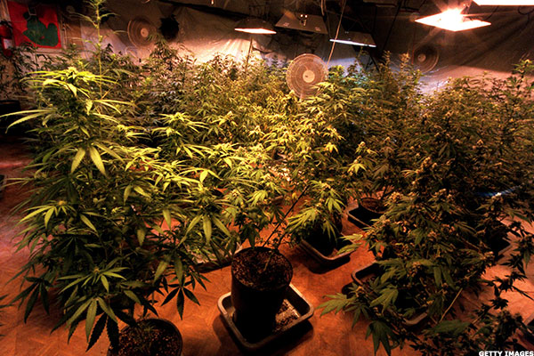

NEW YORK ([MainStreet](http://www.mainstreet.com/)) — When a [cannabidiol (CBD) supplier](http://www.mainstreet.com/article/hemp-provision-farm-bill-boon-medical-marijuana" \t "_blank) was approached by Drug Enforcement Administration (DEA) agents at a national trade show in October about the legality of their display and samples, attorney Bob Hoban stepped in.  
  
Read More: [Lending Further Credibility to Legal Pot](http://www.mainstreet.com/article/denver-cannabusiness-summit-lends-further-credibility-pot-industry" \t "_blank)

“The drug enforcement agents did not understand CBD and its distinction from THC,” Hoban told MainStreet. “Nor did they understand the legal difference between industrial hemp plant sourcing and typical pot plant sourcing. They thought it was illegal.”   
  
Based in Denver, Hoban represents fifteen CBD companies including[Cannavest](http://www.mainstreet.com/article/hemp-provision-farm-bill-boon-medical-marijuana" \t "_blank), a CBD oil supplier.  
  
“Agents approached the booth and began to inquire as to what made my client think that they could possess and display the CBD products at the trade show, because they were not a medical marijuana licensee in that state,” Hoban said. “I happened to be there at the time and the owner deferred to me.”   
  
**Read More:** [Why the Elderly Matter in Pot Reform](http://www.mainstreet.com/article/why-elderly-matter-floridas-fight-legalize-pot" \t "_blank)

[Armed with legal analysis based on the Hemp Industries Association legal case](http://www.mainstreet.com/article/god-bless-united-states-hemp" \t "_blank), the DEA agents were hard pressed to argue with Hoban.   
  
“Marijuana laws generally prohibit cannabis sativa L. and any part thereof and as a part of that plant CBD is illegal,” said Abel. “Those who say it is legal are relying on an interpretation of the Hemp Industries Association case.”   
  
Hoban was able to convince DEA agents and their supervisor of the [legality](http://www.mainstreet.com/article/are-marijuana-stocks-shady" \t "_blank)of his client’s CBD display at the Natural Products Supply Side trade show in New York City.   
  
The analysis that Hoban relied on stated that the sale, production and distribution of CBD oils and products derived from imported raw material industrial hemp is legal because the 9th Circuit ruled that naturally occurring cannabinoids in industrial hemp foods, including oil, were never [scheduled under the Controlled Substances Act (CSA).](http://www.mainstreet.com/video/cannabis-legalization-evangelists-found-purpose-in-difficult-loss" \t "_blank)  
  
Read More: [Cannabis Legalization From Bloodshed to Regrowth](http://www.mainstreet.com/article/cannabis-legalization-bloodshed-regrowth" \t "_blank)  
  
“You can import hemp legally and sell it legally but you can’t grow it commercially here in the U.S.,” said Adam Laufer, an attorney and co-CEO of MJ Holdings in Miami.   
  
Although industrial hemp fiber, stalk, seed and oils can be lawfully imported into the United States, currently a license is required to extract CBD lawyfully. Engineering the growth of marijuana with less than 0.07% THC in it is also legal.   
  
“That’s how CBDs will be cultivated legally if and once the Farm Bill is broadened,” Laufer told *Mainstreet*.   
  
Industrial hemp cultivation is legal in Colorado, Oregon, California, Kentucky, Vermont, Montana, West Virginia, North Dakota and Maine, among other states.  
  
“The budget bill passed by Congress last week cuts the DEAs funding for any [marijuana enforcement i](http://www.mainstreet.com/article/congress-tackles-marijuana-next-years-budget" \t "_blank)n any lawful/medical state,” said Hoban. “It also prevents the DEA from spending any money on CBD enforcement.”   
  
*—Written for MainStreet by Juliette Fairley*