**Stanford University Study Finds That Marijuana Could Help With Autism**

[**http://www.opposingviews.com/i/health/stanford-university-study-finds-marijuana-could-help-autism**](http://www.opposingviews.com/i/health/stanford-university-study-finds-marijuana-could-help-autism)

 3363

 47

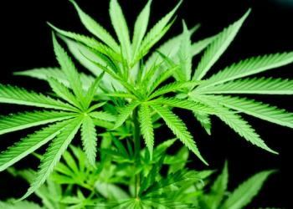

By [Evan Bleier](http://www.opposingviews.com/users/evan-bleier), Fri, July 26, 2013

A study conducted by Stanford University has found that there might be compounds in marijuana which have some very specific health benefits.

The study’s results reveal that cannabinoids – which are found in cannabis – might help to treat autism.

“A new study shows that mutations associated with autism block the action of brain molecules that act on the same receptors that marijuana’s active chemical acts on,” according to the Autism Daily Newscast. “Thomas Sudhof, a cellular physiologist at Stanford University, tested mutations associated with autism in mice. Two mutations associated with autism in a synapse-adhesion protein led to deficits in prolonged endocannabinoid signaling in mice. This suggests that autism could caused by a disruption of the brain’s ability to send clear signals.”

[ADN references](http://www.theweedblog.com/study-finds-cannabis-may-provide-treatment-for-autism/) another study that supports the theory that cannabinoids could be used as a treatment to autism.

“Danielle Piomelli of UC Irvine and Olivier Manzoni of INSERM, the French national research agency, treated mice exhibiting symptoms of Fragile-X Syndrome, a disorder that causes autistic symptoms, with novel compounds that correct the signaling of endocannibinoid transmitters in the brain [which cannabinoids can do]. The mice showed dramatic behavioral improvements in maze tests measuring anxiety and open-space acceptance.”

ADN clearly believes that [the study’s findings](http://thejointblog.com/study-finds-cannabis-may-provide-treatment-for-autism/) should be viewed as a reason for hope.

“Families who are already using the drug to treat their children’s symptoms believe it has made all the difference in the world. Many children with autism are already given cocktails of drugs that may be even stronger than marijuana, with serious side effects and limited results.”

Sources: [The Weed Blog](http://www.theweedblog.com/study-finds-cannabis-may-provide-treatment-for-autism/), [The Joint Blog](http://thejointblog.com/study-finds-cannabis-may-provide-treatment-for-autism/)

- See more at: http://www.opposingviews.com/i/health/stanford-university-study-finds-marijuana-could-help-autism#sthash.UDtXT3So.dpuf